Three New Ancient Tombs Discovered in Egypt

The newfound artifacts span decades of Egyptian history—suggesting the tombs were part of a city’s large cemetery.

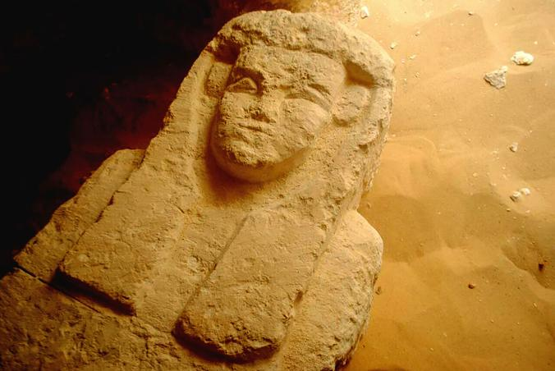

1 / 2

VIEW IMAGES
This sarcophagus was found in a Ptolemaic tomb in an area known as al-Kamin al-Sahraw, in the Nile Valley province of Minya south of Cairo.
PHOTOGRAPH BY EGYPTIAN MINISTRY OF ANTIQUITIES, AP
Egypt's antiquities ministry says that archaeologists have discovered three tombs dating back more than 2,000 years, from the Ptolemaic Period.
PHOTOGRAPH BY EGYPTIAN MINISTRY OF ANTIQUITIES, AP
By Michael Greshko
PUBLISHED AUGUST 16, 2017
The Egyptian Ministry of Antiquities has announced the discovery of three rock-cut tombs in northeast Egypt, each more than 2,000 years old.
The trio of tombs were found about 125 miles south of Cairo, in an area called El-Kamin El-Sahrawi near the city of Samalut. Ministry officialstold the Egyptian news outlet Ahram Online that the tombs contain multiple sarcophagi of various sizes, as well as clay fragments.
The fragments indicate that the tombs span the 27th Dynasty (525 - 404 B.C.), when Egypt first became a province of the Persian Achaemenid Empire, as well as the period of Greco-Roman Ptolemaic rule that began nearly a century later.
"This fact suggests that the area was a large cemetery over a long period of time," said Ayman Ashmawy, head of the Ministry of Antiquities’ Ancient Egyptian Sector, to Ahram Online.
Previous excavations of the site uncovered some 20 tombs built in the style of catacombs, a widespread architectural practice during the 27th Dynasty. The three newly discovered tombs, however, are reportedly different.

0:06

|

0:47

See inside another Egyptian tomb.
Two of the three tombs consist of burial chambers branching off a perpendicular burial shaft, with fifteen burial holes between them—including a small hole carved out for the body of a child. Ali El-Bakry, head of the excavation mission, told Ahram Online that the tomb presents the first evidence of a child burial at El-Kamin El-Sahrawi.

YOU MIGHT ALSO LIKE
- See Inside the Tomb of a High-Powered Egyptian Woman
- 3,000-Year-Old Colossal Pharaoh Statue Moved to New Home
- Magnificent Ancient Buildings Hewn From Living Rock
What’s more, bones recovered from the tombs suggest that the people buried were men, women, and children of different ages—indicating that the site was part of a city’s large cemetery, not a military garrison.
Further finds at El-Kamin El-Sahrawi are virtually certain: Excavations on the third tomb have not yet been completed.

Michael Greshko writes online science news stories on everything from animal behavior to space and the environment.
FOLLOW MICHAEL

